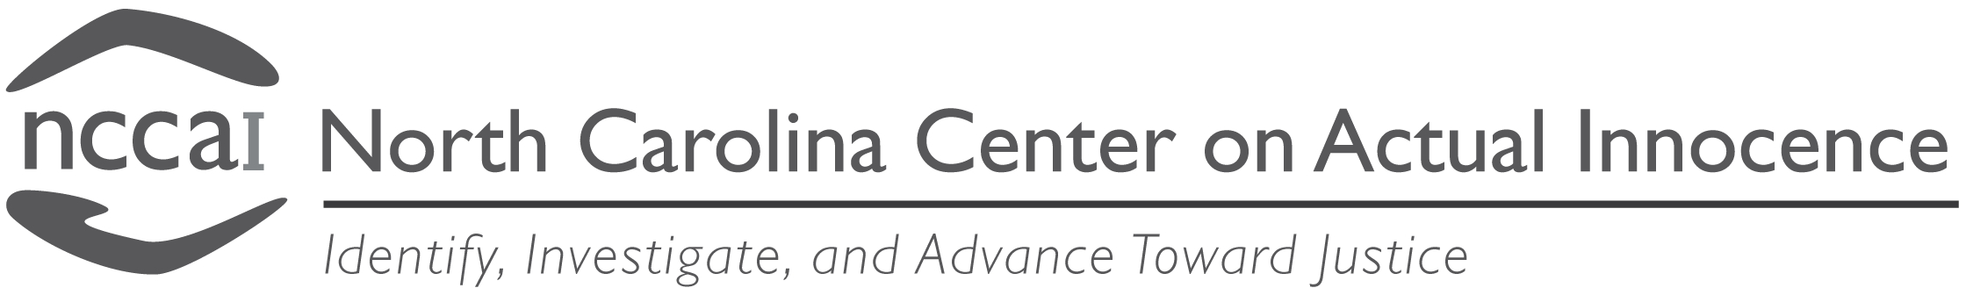

P.O. Box 52446 Shannon Plaza Station, Durham, NC 27717-2446
admin@nccai.org (919) 489-3268 (Phone) (919) 489-3285 (Fax)

CONSENT FOR RELEASE OF INFORMATION

I, _________________________________, hereby authorize any and all entities and persons, including, but not limited to, my former trial attorney(s), my former appellate attorney(s), and my former post-conviction attorney(s) to release to the North Carolina Center on Actual Innocence for its use, or for the use of student or faculty representatives from affiliated or independent Innocence Projects®, any and all records, files, reports, and information of any kind related to me or to any criminal case for which I may have been convicted.

I understand that any information that I give the North Carolina Center on Actual Innocence may be shared with other individuals. This may be done in the context of working on my case, for educational purposes, for fund raising purposes, or any other reason deemed appropriate by the North Carolina Center on Actual Innocence. If I do not wish any information regarding my case to be shared with others, I understand that I must put that specific request in writing. If I had any questions about this policy, I have had the opportunity to contact the North Carolina Center on Actual Innocence for clarification.

I understand that the North Carolina Center on Actual Innocence will undertake such measures as, in its sole judgment and discretion, are necessary and appropriate to evaluate and present reasonably meritorious legal claims in this matter, but that this authorization does not obligate the North Carolina Center on Actual Innocence to represent me in court proceedings without further written commitment by letter to me from the North Carolina Center on Actual Innocence.

I also authorize the North Carolina Center on Actual Innocence to represent me for the limited purpose of determining whether any evidence related to my case is still in the custody of the Clerk of Court of the county in which I was convicted or any law enforcement agency that investigated my case.

By my signature below, I represent that this waiver is voluntary and given without any reservation. I understand that this authorization may be revoked by the undersigned at any time; it is effective until revoked by the undersigned in writing.

Signed this the ____ day of ____________, 202__.

______________________________

Signature

