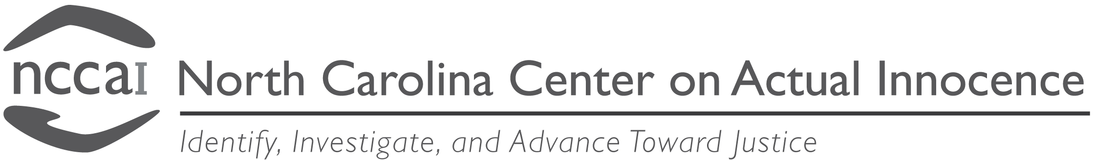

P.O. Box 52446 Shannon Plaza Station, Durham, NC 27717-2446
admin@nccai.org (919) 489-3268 (Phone) (919) 489-3285 (Fax)

CONSENT FOR VICTIM CONTACT

Contacting the victim is not a step we take in every case we review. However, during the course of our investigation we may determine that the best avenue to pursue is to contact the victim(s) in your case. Please check the appropriate box below regarding whether we have your permission to contact the victim(s) should we deem that contact necessary.

I give The North Carolina Center on Actual Innocence permission to contact, _________________________________, the victim(s) in my case. His/her current contact information is (please include his/her current age, address and telephone number, if possible): ________________________________________________________________________________________________________________________________________________________________________________________________________________________________________________________________________________________________________________________

I do not give The North Carolina Center on Actual Innocence permission to contact, _________________________________, the victim(s) in my case. I understand that this will potentially limit The North Carolina Center on Actual Innocence’s ability to assist with my innocence claim.

______________ ____________________________________
Date Print Name

____________________________________
Signature

